LAB REPORT- 2

SUBJECT:-ESE-3014

GROUP - 5

*Submitted By*

*Ankitkumar Patel – C0747455*

*Ronakkumar Sharma - C0747019*

*Professor - linchen*

*Email id - Linchen.wang@cestarcollege.com*

1. Create a 2D plot of the sine function between 0 and 2π.

x=[0:.25:2*pi];

plot(sin(x))

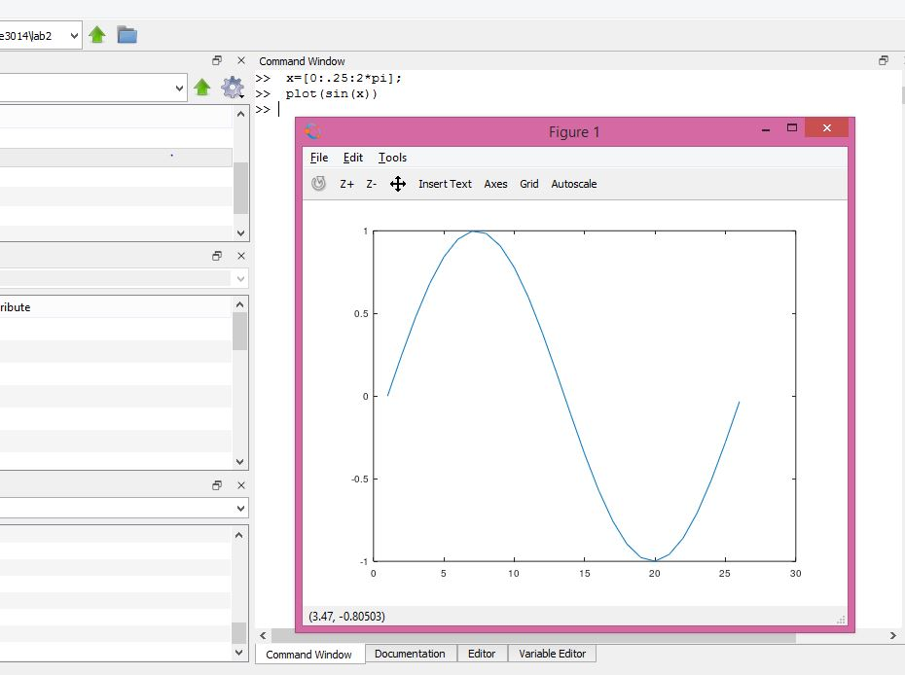

1. Create a 3D plot of a surface by creating a grid along the X and Y axes and plotting the Z-coordinate according to the exponential function.

X=[-2:0.25:2];

Y=X;

[X,Y]=meshgrid(X);

Z=X.*exp(-X.^2-Y.^2);

surf(X,Y,Z);

title('3 -D Plot ');

xlabel('X Axis'), ylabel('Y Axis'),zlabel('Z Axis');

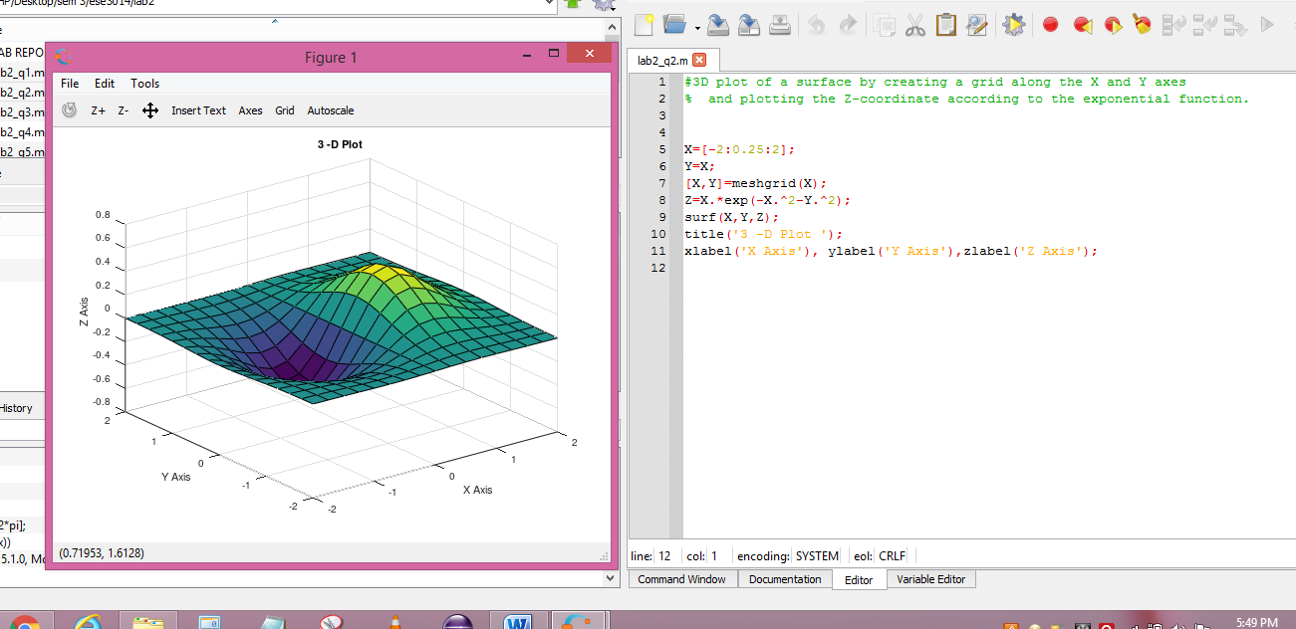

1. Write a script to apply if and if-else statements.

disp('A script to apply if and if-else statements.');

r = input('enter the value of row : ');

v=rand(r,1)

maxval=12;

if any(v > maxval)

disp('There is at least one value above the limit.')

else

disp('All values are below the limit.')

end

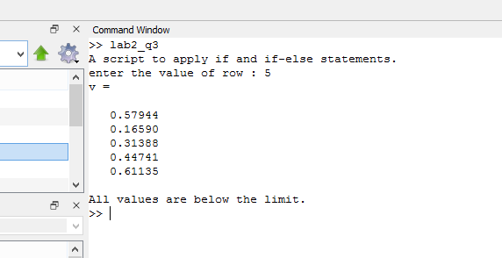

1. Write a script to apply conditional logic switch.

disp (' display of sine and cosine wave')

n = input('enter "1" for sinewave "2" for cosinewave : ')

x=[0:.1:4*pi]

switch n

case 1

plot(sin(x))

case 2

plot(cos(x))

otherwise

disp('you are fucking guy')

end

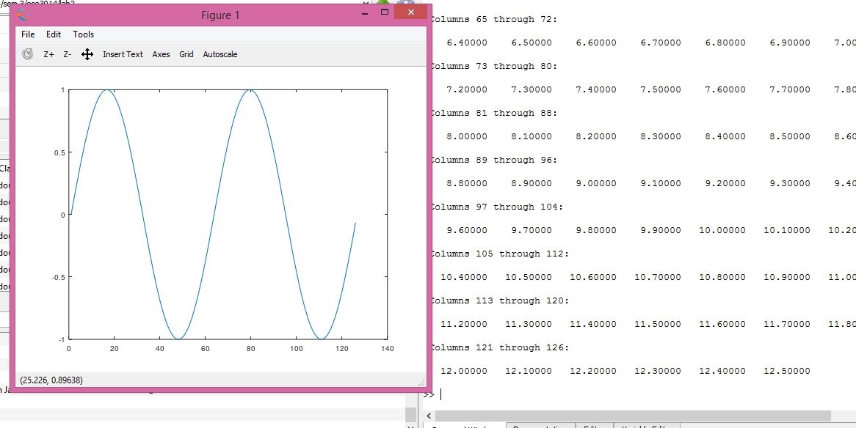

1. Write a script to perform loop with a while condition.

clc;close all;

A= 0;

while (A< 10)

fprintf(" value of A is %d\n" , A);

A+=1;

end

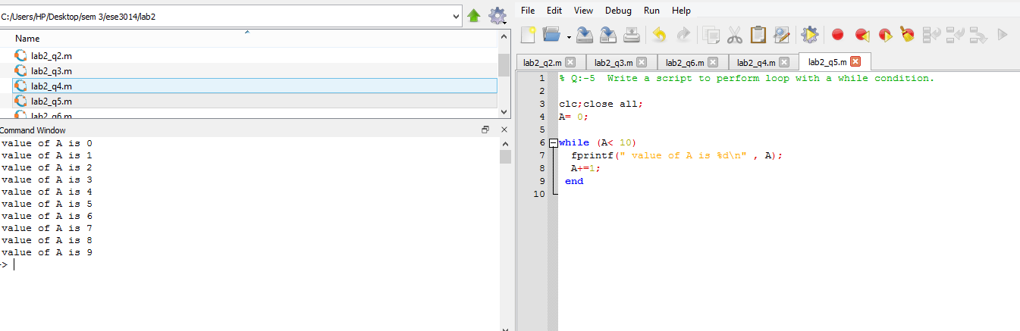

1. Write a script to plot a vector of random data. Draw a horizontal line at the mean. Save the script and run it from the command line.

sample=50;

random_vec=rand(sample,1) %Vector of 50 random number

hold on;

plot(random_vec);

m=mean(random_vec);

plot([0,sample],[m,m]);

title(' Random data and Mean line ');

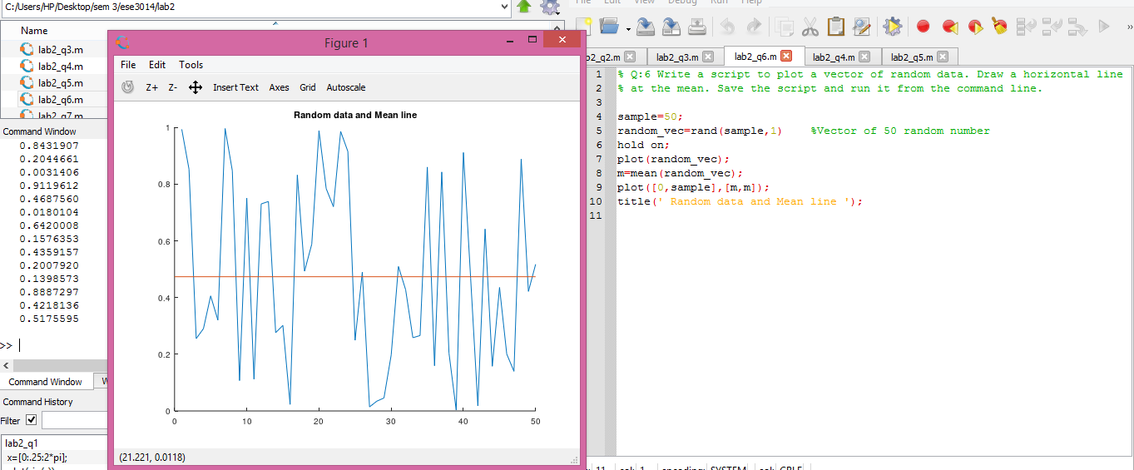

1. Write a script that calculates the mean of five samples of data from a vector of random data. Calculate the overall mean. Use a for loop to perform the calculations. For each iteration of the loop print out the intermediate results. Use an if..else control block to display the results depending on whether the mean of the samples is less than, greater than or equal to the overall mean.

sample=50;

random_vec=rand(sample,1) %Vector of 50 random number

randVec_5_sample=randsample(random_vec,5) % 5 random samples from vector

% overall mean

sum=0;

for i=1:length(random_vec)

sum=sum + random_vec(i);

end

mean_overall= sum/length(random_vec)

% Mean of 5 samples from randon number vectpr

sum1=0.0;

for j=1:5

sum1=sum1+randVec_5_sample(j);

mean_In=sum1/j;

fprintf("\nIntermediate mean #%d is: %0.3f \n", j, mean_In);

end

mean_5_samples= sum1/5

% comparing mean of 5 samples to Overall mean

if(mean_5_samples< mean_overall)

fprintf(" \nMean of 5 Samples is Less than Overall Mean");

elseif (mean_5_samples > mean_overall)

fprintf(" \nMean of 5 Samples is greater than Overall Mean");

elseif(mean_5_samples = mean_overall )

fprintf(" \nMean of 5 Samples is Equall to Overall Mean");

end

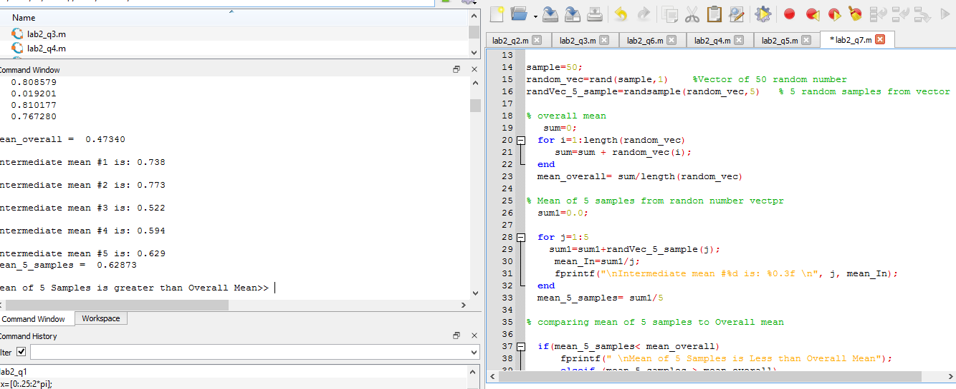

1. Create a function that calculates the area of a circle with the radius as input in command window. Call this function from the MATLAB command line or in a MATLAB script (.m).

clc;close all;

r=input("Enter the radius of Circle : ")

disp(" Area of circle is : ")

A= pi*r*r

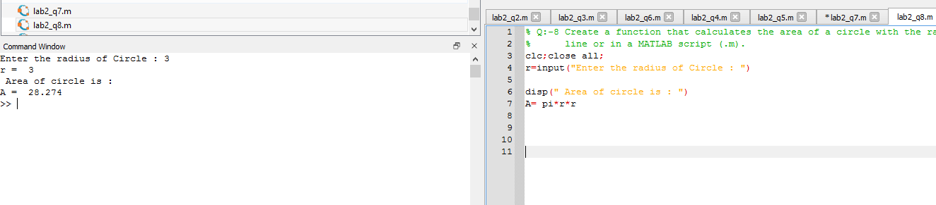

1. Create a function that calculates the sum of an arbitrary number of sinusoidal terms. Call this function from the MATLAB command line or in a MATLAB script (.m).

t=0:0.1:2*pi;

% first Sine term

subplot(2,2,1);

X=sin(2*t);

plot(X);

title('SIne 2*t ');

xlabel('Time'), ylabel('Amplitude');

% Second Sine term

subplot(2,2,2);

Y=sin(4*t);

plot(Y);

title('SIne 4*t ');

xlabel('Time'), ylabel('Amplitude');

% Third Sine term

subplot(2,2,3);

Z=sin(6*t);

plot(Z);

title('SIne 6*t ');

xlabel('Time'), ylabel('Amplitude');

% Addition of three sine terms

subplot(2,2,4);

Sum=X+Y+Z;

plot(Sum);

title('Sinusoidal tems addition ');

xlabel('Time'), ylabel('Amplitude');

